Fermi-Dirac Statistics and Semiconductors
In a semiconductor we are really interested in considering electrons in the valence band or conduction band. In an intrinsic semiconductor we know that the valence band is full and the conduction band is empty at 0 K. However, as the temperature rises there becomes a finite probability of some electrons jumping up to the conduction band and becoming conducting (as well as leaving a conducting hole behind).
In order to help us calculate this we can use Fermi-Dirac Statistics:
Let us define P(E) as the probability that an electron has energy, E (at some temperature, T)
Now as our particles are electrons, which obey the Pauli Exclusion Principle we need to use Fermi-Dirac Statistics, which has a function:
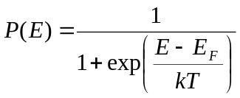, where E_{F} is the FERMI LEVEL
Let us first consider the temperature at absolute zero.
It is trivial to show that if E> E_{F} that P(E)=0 and similarly that if E<E_{F} that P(E)=1
Thus if we are at an energy below E_{F} we are certain to find and electron (all levels are full) and above it we will certainly not find one (all levels are empty).
Plotting E against P(E) gives

Now let us replot E against P(E) for the situation where T is increased.

In this case there is some probability of finding and electron above E_{F} and similarly some probability of not finding an electron below E_{F}.. The probability of these things happening will INCREASE as the temperature increases:

Note that the function is symmetrical -- P(E+δE) = 1- P(E-δE) and that P(E)=0.5 at E=E_{F}.

Application to Semiconductors
In a semiconductor we now have a bandgap between the conduction band and valence band.

Making a simplification that Eg is much larger than the width in Energy of the two allowed bands, the probability that an electron can get into the conduction band at some temperature, T can be given by P(E_{v}+E_{g}):
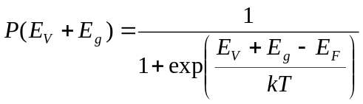
If there is a density of n electrons in the conduction band at T then
n=total number of electrons x probability of an electron being in the conduction band: 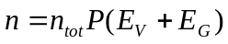
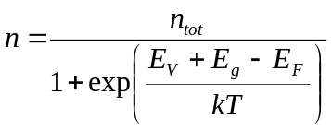
Similarly we can show that n_{V} the density of electrons in the valence band is given by
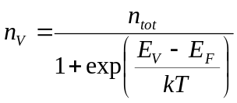
Now 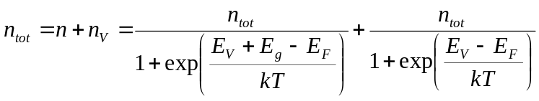
*****EXERCISE**** Rearrange the above equation to show that 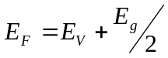
This result means that in an intrinsic semiconductor the Fermi Level is midway between the valence band and the conduction band. Note that as the function is symmetric the probability of an electron being in the conduction band is exactly the same as finding the absence of an electron in the valence band. This means as expected the intrinsic carrier concentration n_{i}=n=p
Thus we can write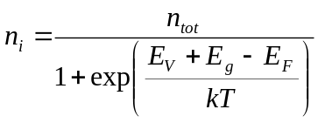
From we get 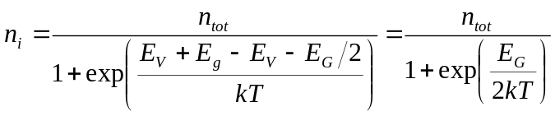
This is a similar result to that we gave at the beginning of this course (see first lecture), although this is a simplified form because of the approximation we made that the bands were much thinner in energy than the gap between them.

Doping Revisited
We have already said that doping can lead to extra free electrons or holes. When we dope a material with a suitable impurity the impurity behaves rather like a hydrogen atom, except the energy holding the electron to the impurity is typically a few meV, rather than 13.6 eV in hydrogen. This is called the binding energy of the impurity.
We can represent a donor state as a level in the forbidden gap. It will removed downwards from the bottom of the conduction band by an amount equal to the binding energy.
Similarly for an acceptor the state is a level removed upwards from the top of the valence band by the binding energy.
The impurity binding energies in most semiconductors are so small that at room temperature the electrons in the donor state can essentially all jump out and move freely in the conduction band, and similarly holes for acceptor states can escape the acceptor atom and freely move in the valence band.
Note that the generation recombination relationship always holds so if in n-type material the number of free electrons increases then this will dramatically suppress the concentration of the residual holes.

Doping and the Fermi Level
We also need to know how the position of the Fermi Level changes with doping.
Now in intrinsic material n=p and E_{F} was mid bandgap.
For n-type material n>>p (eg if n_{i}=10¹⁶ m⁻³ for a material and it is doped to n=10²² m⁻³ then p_{n} (density of holes in the n-type material) = 10¹⁰ m⁻³
We can accommodate this by moving the Fermi Level from midgap towards the bottom of the conduction band:
In principle the new Fermi level position will move to be half way between the impurity state and the conduction band edge. We can effectively say that number of electrons thermally excited into the conduction band from the donor states is much, much higher than the number of electrons thermally excited from the valence band. Thus the material is behaving like it has a new bandgap of the difference between the conduction band edge and the impurity energy. (Remember though that the total number of electrons from the impurities is a very tiny fraction that the number in the valence band.

Note that at very high temperatures (normally well above room temperature) then thermal excitation from the valence band will again start to become significant. As the intrinsic carrier concentration rises so the Fermi level will start to drop back to the midgap position. Higher N_{d} (concentration of donors) will delay this onset with temperature.

All these arguments can equally be applied to p-type material in reverse. (eg the Fermi level moves from near the valence band edge upwards towards midgap as the temperature rises way above room temperarture..

Compensation Doping
In many semiconductors we have the situation that the material has both types of dopant present. This can happen either as a result of manufacturing, eg implanting a low density of dopant, in a large volume of material, followed by a higher density of the opposite type in a small volume which is part of that volume. This is one way to make a diode for example.
Adding dopants still leaves the material, electrically neutral: When a dopant releases a free electron or free hole, it leaves behind an ionized dopant centre of the opposite charge. Hence if there are N_{A} and N_{D} acceptors and donors, respectively; and n and p free electrons and holes, then because of charge neutrality: negative charge = positive charge,
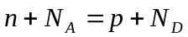, and as before in any material 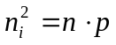
Combining these equations we can get: 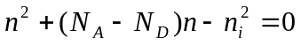
And the roots of the quadratic are simply 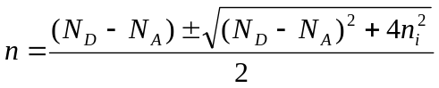
The first term gives the carriers from the dopants and the second the intrinsically generated carriers.
Extrinisically Doped Material
In deliberately doped material, N_{D}>>N_{A}
In this case (N_{D}-N_{A})>>n_{i} and the second term will tend to 1 and n will be simply N_{D}-N_{A} to a first approximation.
We can show that p is very small in this case for an n-type semiconductor.
Intrinsically Doped Material
In such material the extrinisic material (eg p-type) has been doped with donor to try to compensate the free holes and bring the material back to an intrinsic carrier concentration.
In this case the aim is that the carrier concentration due to dopants will be close to zero and the main population of free carriers will be those that are thermally generated.
Thus n_{i}>>|N_{D}-N_{A}|
In the second term the first part will now be negligible and
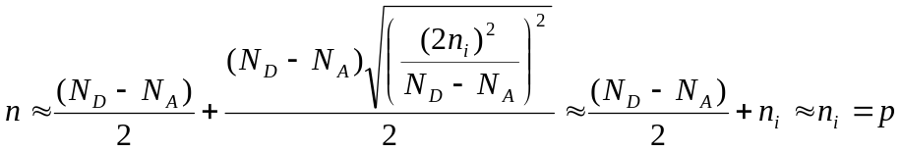
In reality it is nearly impossible to control dopants at the level of the intrinsic carrier concentration and thus compensated material is always extrinsic to some degree.

